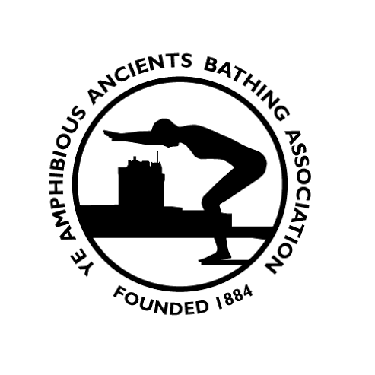

OPEN WATER SWIM RESULTS 2021

Authorised and Released: Version 1.0 on 18 July 2022

Contents
Table of Contents
Contents 2
RECORD OF CHANGES 3
Introduction 4
Monifieth 4
Senior Women 4
Stannergate 4
Senior Men 4
Junior Womer 4
Junior Men 5

RECORD OF CHANGES

Date | Changes | Version
18 Jul 2022 | Initial Issue | 1.0

Introduction
The document records the outcomes of the YeAABA swims held during the 2022 Season.

Monifieth
Date : Sun 22 Aug 21
Distance : 3.25 Mile
Overall Winner : Mhairi Murdoch
Senior Women
Name Club Str Time
1 Mhairi Murdoch FS 54m 24s
2 Erin Farley BS 1Hr 09m 13s (New Record)
3 Val Lindsay FS 1Hr 10m 48s
Senior Men
Name Club Str Time
1 Steve Adam 55m 45s
2 Robert Mitchell 1Hr 02m 24s

Stannergate
Date : Fri 13 Aug 21
Distance : 1.45 Mile
Overall Winner : Mhairi Murdoch
Senior Women
Name Club Str Time
1 Mhairi Murdoch YeAABA 33m 20s (New Record)
2 Heather Ingram 34m 12s
3 Julie Murdoch YeAABA 51m 48s

Senior Men
Name Club Str Time
1 Kris Copeland YeAABA 37m 34s
2 Robert Mitchell YeAABA 41m 19s

